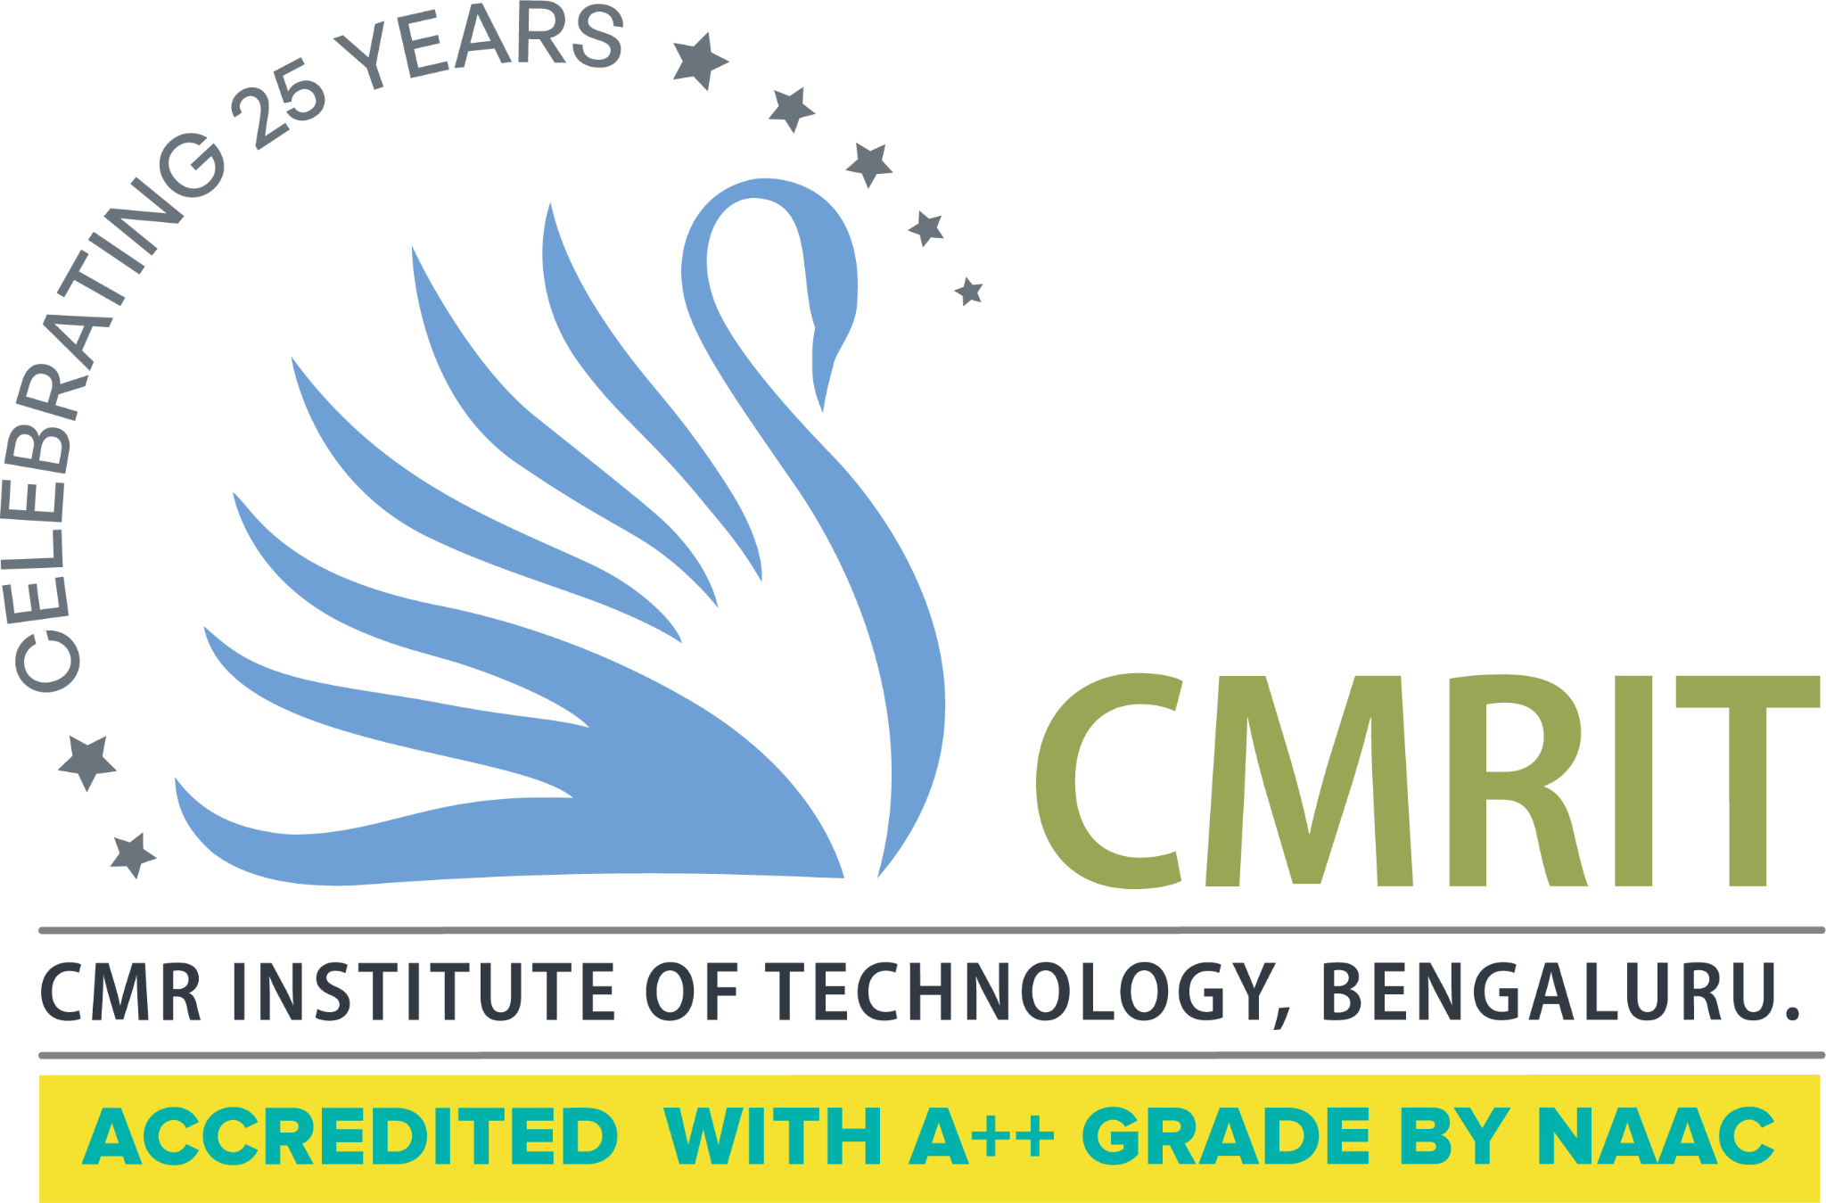
CMR Institute of Technology, Bangalore
Department(s): ISE
Semester: 6 | Section(s): A, B, C | Labs/week: 02+02+02 (per batch)
Subject : DEVOPS LAB |  | Code: BCSL657D
Course Instructor(s): Prof. Vijayshanti, Prof. Nidhi Joshi Parsai, Prof. Jhanavi, Prof. Neeraj, Prof. Bindiya
Course duration: January 26 to June 2026
Course Site: https://classroom.google.com/c/ODQxMTM4OTk4NjM0?cjc=4uqx4arg

Link to detailed syllabus: | https://drive.google.com/drive/folders/1Rs0FzwZzYEaoNGiNEIFznh1kU6YTsIu9
Course Objectives/  Expectations | - To introduce DevOps terminology, definition & concepts  - To understand the different Version control tools like Git, Mercurial  - To understand the concepts of Continuous Integration/ Continuous Testing/ Continuous Deployment)  - To understand Configuration management using Ansible  - Illustrate the benefits and drive the adoption of cloud-based Devops tools to solve real world problems
Prerequisites | - Basic knowledge of Java programming and software development lifecycle  - Familiarity with Linux/Unix commands and working in a command-line environment  - Fundamental understanding of Git version control concepts  - Introductory awareness of CI/CD, build tools, and cloud computing concepts

NOTE: First one to two sessions should be marked for expectations setting about the course.

Lesson Plan
Lab No | Experiments | Portions coverage
Lab No | Experiments | Teaching Aids/Course Delivery Methods | % of Syllabus Covered
1 | Introduction to Maven and Gradle: Overview of Build Automation Tools, Key Differences Between Maven and Gradle, Installation and Setup | Build Automation Tool | 8%
2 | Working with Maven: Creating a Maven Project, Understanding the POM File, Dependency Management and Plugins | Maven | 8%
3 | Working with Gradle: Setting Up a Gradle Project, Understanding Build Scripts (Groovy and Kotlin DSL), Dependency Management and Task Automation | Gradle | 8%
4 | Practical Exercise: Build and Run a Java Application with Maven, Migrate the Same Application to Gradle | Migration | 8%
5 | Introduction to Jenkins: What is Jenkins?, Installing Jenkins on Local or Cloud Environment, Configuring Jenkins for First Use | Jenkins | 8%
6 | Continuous Integration with Jenkins: Setting Up a CI Pipeline, Integrating Jenkins with Maven/Gradle, Running Automated Builds and Tests | Pipeline | 8%
7 | Configuration Management with Ansible: Basics of Ansible: Inventory, Playbooks, and Modules, Automating Server Configurations with Playbooks, Hands-On: Writing and Running a Basic Playbook | Ansible | 8%
8 | Practical Exercise: Set Up a Jenkins CI Pipeline for a Maven Project, Use Ansible to Deploy Artifacts Generated by Jenkins | Jenkins | 10%
9 | Introduction to Azure DevOps: Overview of Azure DevOps Services, Setting Up an Azure DevOps Account and Project | Azure | 8%
10 | Creating Build Pipelines: Building a Maven/Gradle Project with Azure Pipelines, Integrating Code Repositories (e.g., GitHub, Azure Repos), Running Unit Tests and Generating Reports | Azure Repos | 8%
11 | Creating Release Pipelines: Deploying Applications to Azure App Services, Managing Secrets and Configuration with Azure Key Vault, Hands-On: Continuous Deployment with Azure Pipelines | Azure Repos | 8%
12 | Practical Exercise and Wrap-Up: Build and Deploy a Complete DevOps Pipeline, Discussion on Best Practices and Q&A | Project | 10%

Suggested Learning Resources:

● https://www.geeksforgeeks.org/devops-tutorial/

● https://www.javatpoint.com/devops

● https://www.youtube.com/watch?v=2N-59wUIPVI

● https://www.youtube.com/watch?v=87ZqwoFeO88

Syllabus for Internal Assessment Tests (IAT*)

IAT # | Syllabus
IAT-1 | Exp 1-6
IAT-2 | Exp 7-12
*See calendar of events for IAT schedule.

Evaluation:
- Assessment Details (both CIE and SEE): The weightage of Continuous Internal Evaluation (CIE) is 50% and for Semester End Exam (SEE) is 50%. The minimum passing mark for the CIE is 40% of the maximum marks (20 marks out of 50) and for the SEE minimum passing mark is 35% of the maximum marks (18 out of 50 marks). A student shall be deemed to have satisfied the academic requirements and earned the credits allotted to each subject/ course if the student secures a minimum of 40% (40 marks out of 100) in the sum total of the CIE (Continuous Internal Evaluation) and SEE (Semester End Examination) taken together
- Continuous Internal Evaluation (CIE): CIE marks for the practical course are 50 Marks. The split-up of CIE marks for record/ journal and test is in the ratio 60:40. ● Each experiment is to be evaluated for conduction with an observation sheet and record write-up. Rubrics for the evaluation of the journal/write-up for hardware/software experiments are designed by the faculty who is handling the laboratory session and are made known to students at the beginning of the practical session. ● Record should contain all the specified experiments in the syllabus and each experiment write-up will be evaluated for 10 marks. ● Total marks scored by the students are scaled down to 30 marks (60% of maximum marks). ● Weightage to be given for neatness and submission of record/write-up on time. ● Department shall conduct a test of 100 marks after the completion of all the experiments listed in the syllabus. ● In a test, test write-up, conduction of experiment, acceptable result, and procedural knowledge will carry a weightage of 60% and the rest 40% for viva-voce. ● The suitable rubrics can be designed to evaluate each student’s performance and learning ability. ● The marks scored shall be scaled down to 20 marks (40% of the maximum marks). The Sum of scaled-down marks scored in the report write-up/journal and marks of a test is the total CIE marks scored by the student.
Evaluation Method | Remarks
- IAT= 2 IATs each of 50-50 marks and average of marks are scaled down to 20 Marks
- Continuous Evaluation=20 Marks
- Record/Observation Book Marks: 10 Marks
- Total=50(20+20+10) Marks

Virtual Lab (for lab subject only). Provide the details of various tools for learning, including additional web-resources, video-lectures, animated demonstrations and self-evaluation.
NA
please provide the link to access the virtual lab information | -

Mention the best practices identified as part of teaching this subject
- Follow hands-on, experiment-driven learning, where each DevOps concept is immediately reinforced through practical implementation.
- Encourage version control–first practices, ensuring all lab work is managed using Git with proper commit messages and branching.
- Adopt CI/CD pipeline–oriented teaching, integrating build, test, and deployment stages using tools like Jenkins and Azure DevOps
- Emphasize automation and reproducibility, using Ansible playbooks and pipeline scripts instead of manual configurations.

Mention the Importance of this subject along with Real Time Applications
Importance of this subject
- The subject equips students with practical DevOps skills for automating build, test, deployment, and configuration processes used in modern software development.
- It has direct real-time applications in IT industries, including CI/CD pipelines, cloud-based deployments, and infrastructure automation.
- The course enhances industry readiness and employability by exposing students to widely used DevOps tools and practices.

Course Outcomes (COs)
At the end of the course the student will be able to:
● Demonstrate different actions performed through Version control tools like Git.
● Perform Continuous Integration and Continuous Testing and Continuous Deployment using Jenkins by building and automating test cases using Maven & Gradle.
● Experiment with configuration management using Ansible.
● Demonstrate Cloud-based DevOps tools using Azure DevOps.

Course Outcomes |  | Blooms Level | PO1 | PO2 | PO3 | PO4 | PO5 | PO6 | PO7 | PO8 | PO9 | PO10 | PO11 | PO12 | PSO1 | PSO2 | PSO3 | PSO4
CO1 | To introduce DevOps terminology, definition & concepts | L1,2 | 2 | 2 | - | - | - | - | - | - | 2 | - | - | - | - | - | 2 | -
CO2 | To understand the different Version control tools like Git, Mercurial | L2 | 2 | 2 | - | - | - | - | - | - | 2 | - | - | - | - | - | 2 | -
CO3 | To understand the concepts of Continuous Integration/ Continuous Testing/ Continuous Deployment) | L3 | 2 | 2 | - | - | - | - | - | - | 2 | - | - | - | - | - | 2 | -
CO4 | To understand Configuration management using Ansible | L3 | 2 | 2 | - | - | - | - | - | - | 2 | - | - | - | - | - | 2 | -
CO5 | Illustrate the benefits and drive the adoption of cloud-based Devops tools to solve real world problems | L3 | 2 | 2 | - | - | - | - | - | - | 2 | - | - | - | - | - | 2 | -

Identified curriculum gap if any and Justification:
Identified Gap | Justification
- CI/CD, configuration management, and cloud DevOps tools  - infrastructure as code (IaC) | The syllabus provides strong exposure to CI/CD, configuration management, and cloud DevOps tools, but offers limited hands-on practice with containerization technologies such as Docker and Kubernetes, which are widely used in modern DevOps workflows.  Advanced topics like infrastructure as code (IaC) using tools such as Terraform and monitoring/logging tools (Prometheus, Grafana) are not explicitly included.
Proposed Actions to fill the identified gaps:
- Conduct value-added sessions/workshops on modern DevOps tools such as Docker, Kubernetes, and Terraform.
- Introduce mini-projects and case studies focusing on containerized CI/CD pipelines and real-world deployment scenarios.

Course Instructor Signature/s CCI Signature HOD

Appendix
Table 01: Cognitive Levels
Cognitive Levels
Cognitive level | Revised Blooms Taxonomy Keywords
L1 | List, define, tell, describe, identify, show, label, collect, examine, tabulate, quote, name, who, when, where, etc.
L2 | summarize, describe, interpret, contrast, predict, associate, distinguish, estimate, differentiate, discuss, extend
L3 | Apply, demonstrate, calculate, complete, illustrate, show, solve, examine, modify, relate, change, classify, experiment, discover.
L4 | Analyze, separate, order, explain, connect, classify, arrange, divide, compare, select, explain, infer.
L5 | Assess, decide, rank, grade, test, measure, recommend, convince, select, judge, explain, discriminate, support, conclude, compare, summarize.

Table 02: Program Outcomes (PO) and Program Specific Outcomes (PSO)
Program Outcomes (PO), Program Specific Outcomes (PSO)
PO1 | Engineering knowledge: Apply the knowledge of mathematics, science, engineering fundamentals, and an engineering specialization to the solution of complex engineering problems.
PO2 | Problem analysis: Identify, formulate, review research literature, and analyze complex engineering problems reaching substantiated conclusions using first principles of mathematics, natural sciences, and engineering sciences.
PO3 | Design/development of solutions: Design solutions for complex engineering problems and design system components or processes that meet the specified needs with appropriate consideration for the public health and safety, and the cultural, societal, and environmental considerations.
PO4 | Conduct investigations of complex problems: Use research-based knowledge and research methods including design of experiments, analysis and interpretation of data, and synthesis of the information to provide valid conclusions.
PO5 | Modern tool usage: Create, select, and apply appropriate techniques, resources, and modern engineering and IT tools including prediction and modelling to complex engineering activities with an understanding of the limitations.
PO6 | The engineer and society: Apply reasoning informed by the contextual knowledge to assess societal, health, safety, legal and cultural issues and the consequent responsibilities relevant to the professional engineering practice.
PO7 | Environment and sustainability: Understand the impact of the professional engineering solutions in societal and environmental contexts, and demonstrate the knowledge of, and need for sustainable development.
PO8 | Ethics: Apply ethical principles and commit to professional ethics and responsibilities and norms of the engineering practice.
PO9 | Individual and team work: Function effectively as an individual, and as a member or leader in diverse teams, and in multidisciplinary settings.
PO10 | Communication: Communicate effectively on complex engineering activities with the engineering community and with society at large, such as, being able to comprehend and write effective reports and design documentation, make effective presentations, and give and receive clear instructions.
PO11 | Project management and finance: Demonstrate knowledge and understanding of the engineering and management principles and apply these to one’s own work, as a member and leader in a team, to manage projects and in multidisciplinary environments.
PO12 | Life-long learning: Recognize the need for, and have the preparation and ability to engage in independent and life-long learning in the broadest context of technological change.
PSO1 | Implement and maintain enterprise solutions using latest technologies.
PSO2 | Develop and simulate wired and wireless network protocols for various network applications using modern tools.
PSO3 | Apply the knowledge of Information technology and software testing to maintain legacy systems.
PSO4 | Apply knowledge of web programming and design to develop web based applications using database and other technologies.

Table 03: Correlation Levels
Correlation Levels
0 | No Correlation
1 | Slight/Low
2 | Moderate/ Medium
3 | Substantial/ High

